1. Which are the top three variables in your model which contribute most towards the probability of a lead getting converted?

Ans: As per our model, the top three variables which contribute towards the probability of a lead getting converted are:

* 1. Lead source – If the lead source is “Google” it’s most likely to get converted.
  2. Last notable activity – If the last activity is “SMS sent”, it’s most likely to get converted.
  3. Total time spent on website – Higher the total time spent on website, higher are the chances of lead getting converted.

1. What are the top 3 categorical/dummy variables in the model which should be focused the most on in order to increase the probability of lead conversion?

Ans: Top 3 categorical/dummy variables in the model which should be focused the most on in order to increase the probability of lead conversions are:

* 1. Lead Origin_Lead Add Form
  2. Lead Source_Olark Chat
  3. Last Activity_Converted to Lead

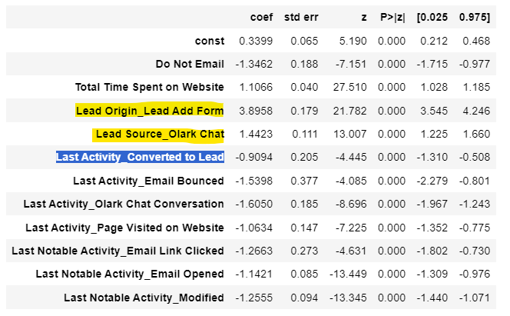

1. X Education has a period of 2 months every year during which they hire some interns. The sales team, in particular, has around 10 interns allotted to them. So during this phase, they wish to make the lead conversion more aggressive. So they want almost all of the potential leads (i.e. the customers who have been predicted as 1 by the model) to be converted and hence, want to make phone calls to as much of such people as possible. Suggest a good strategy they should employ at this stage.

Ans: 1. Target leads who spent higher time on website

2. Target leads that has come through google

3. Target leads which is having last notable activity as “SMS sent”

1. Similarly, at times, the company reaches its target for a quarter before the deadline. During this time, the company wants the sales team to focus on some new work as well. So during this time, the company’s aim is to not make phone calls unless it’s extremely necessary, i.e. they want to minimize the rate of useless phone calls. Suggest a strategy they should employ at this stage.

Ans: 1. Don’t focus on leads where specializations are not clear or mentioned as “select”.

2. Don’t focus on leads where City is Mumbai as chances of leads not getting convert is high.

